LA COUNTY HHW PROPOSAL MEETING WITH STAKEHOLDERS RECAP/NOTES MAY 6, 2026

SWARM: Sustainable Waste and Recycling Management

This is the first meeting. At this meeting LA County staff will discuss the topic of Extended Producer Responsibility (EPR) for Household Hazardous Waste (HHW) and share details about LA County’s efforts to develop a local HHW EPR ordinance including upcoming stakeholder outreach events. “Input from SWARM members and other stakeholders will be critical to help guide the development of safer, more cost-effective, and sustainable HHW programs.”

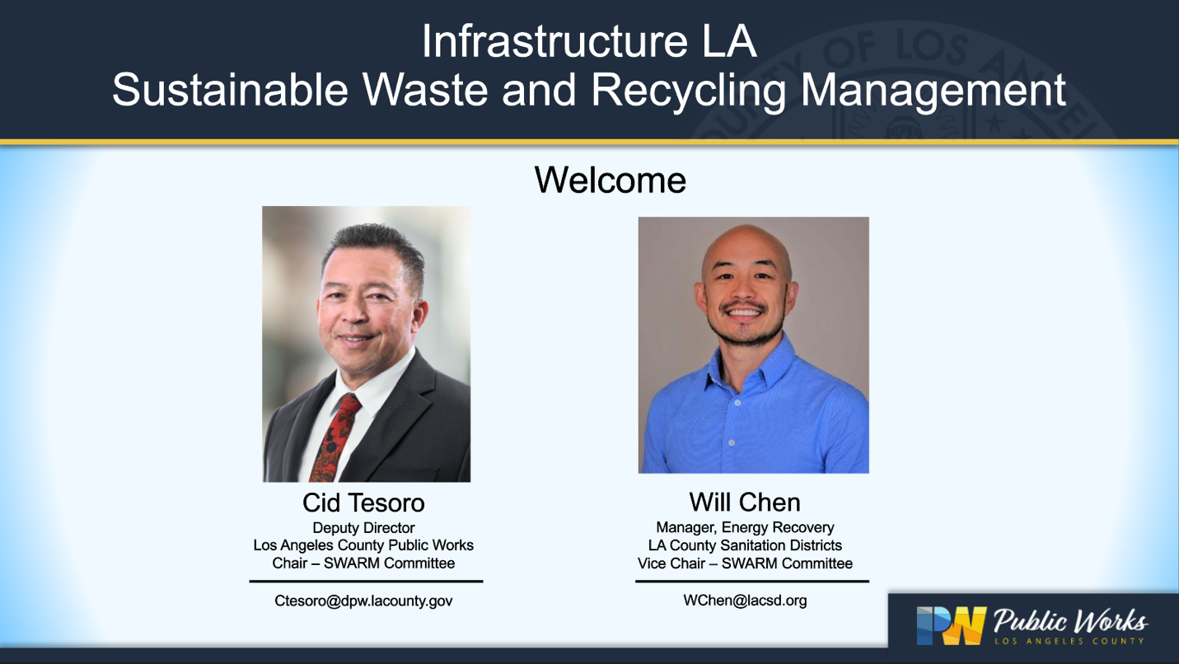

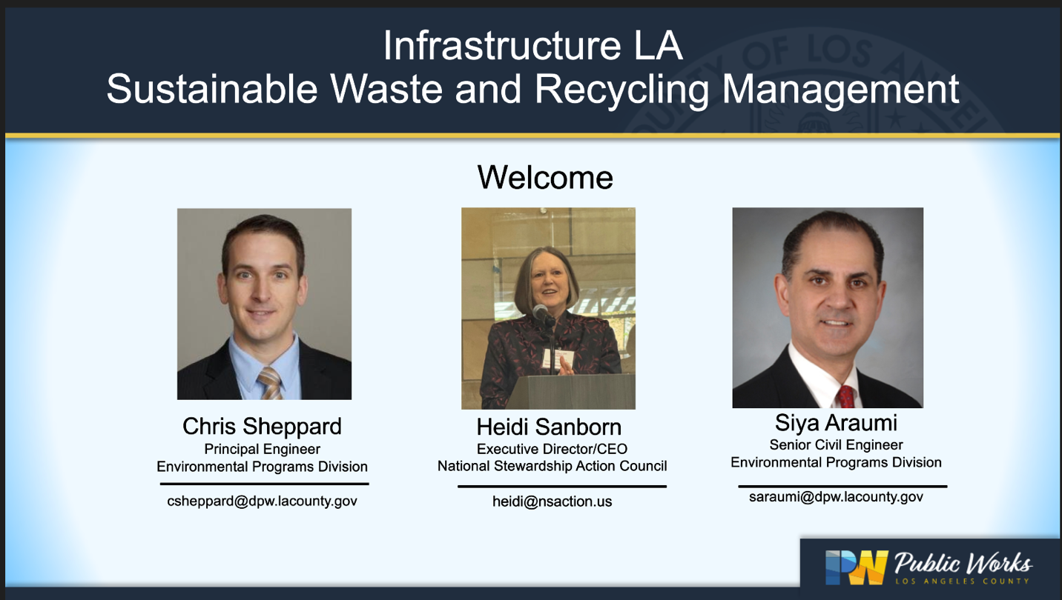

Heidi gave a presentation including information about her organization, history of EPR including Alameda County as the first EPR ordinance in the US.

NSAC’s strategy to get statewide programs through the legislature is by doing what they are doing with HHW EPR now, introducing it locally – jurisdiction by jurisdiction (since Heidi has not been able to get a statewide HHW EPR through the legislature yet – failed four times now)

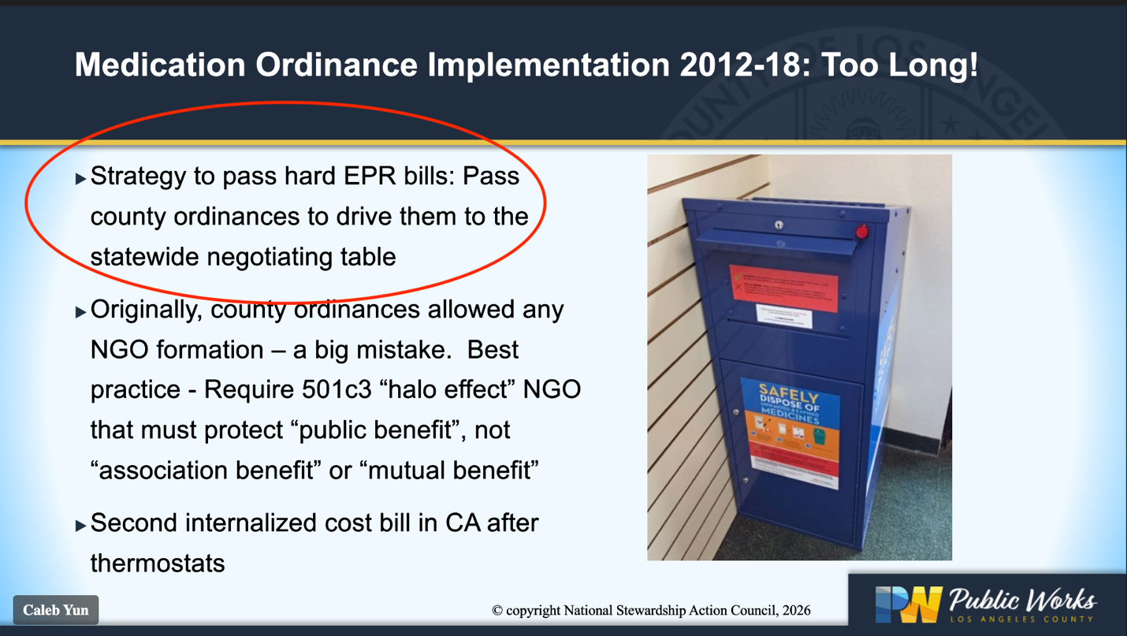
Questions and Answers Following Heidi’s Presentation

Questions from Stakeholders:

Q. Can we learn more about what EPR entails on the producer side?

Heidi: producers need to design the EPR system looking at existing system, try to build on it, use efficiencies that are there, and figure out an entire collection system that meets the goals of the law or ordinance. Producers fund it, contract out work they do not want to do themselves, hire a Producer Responsibility Organization or PRO to run and manage the system.

Q. Does the Vermont HHW cover all labor, insurance and infrastructure costs? Will LA county consider these costs in their prospective ordinance?

Heidi: These are detailed questions about the LA County ordinance, which is not public yet.

Questions asked to Heidi from LA County Staff:

Q. What are top things that make EPR successful?
Heidi: Keeping the bill or ordinance language very clear to avoid confusion, litigation, etc. and giving producers enough time to do what we want them to do. Programs take time to roll out and they are big. We need stakeholder engagement all the way through.

Q. What are some things local governments can do to help EPR?
Heidi: collecting good data and science. We need good numbers on what things are costing, how much work has been done, etc. for collection. We get much data over time when producers take over the program.

LA County Presentation:

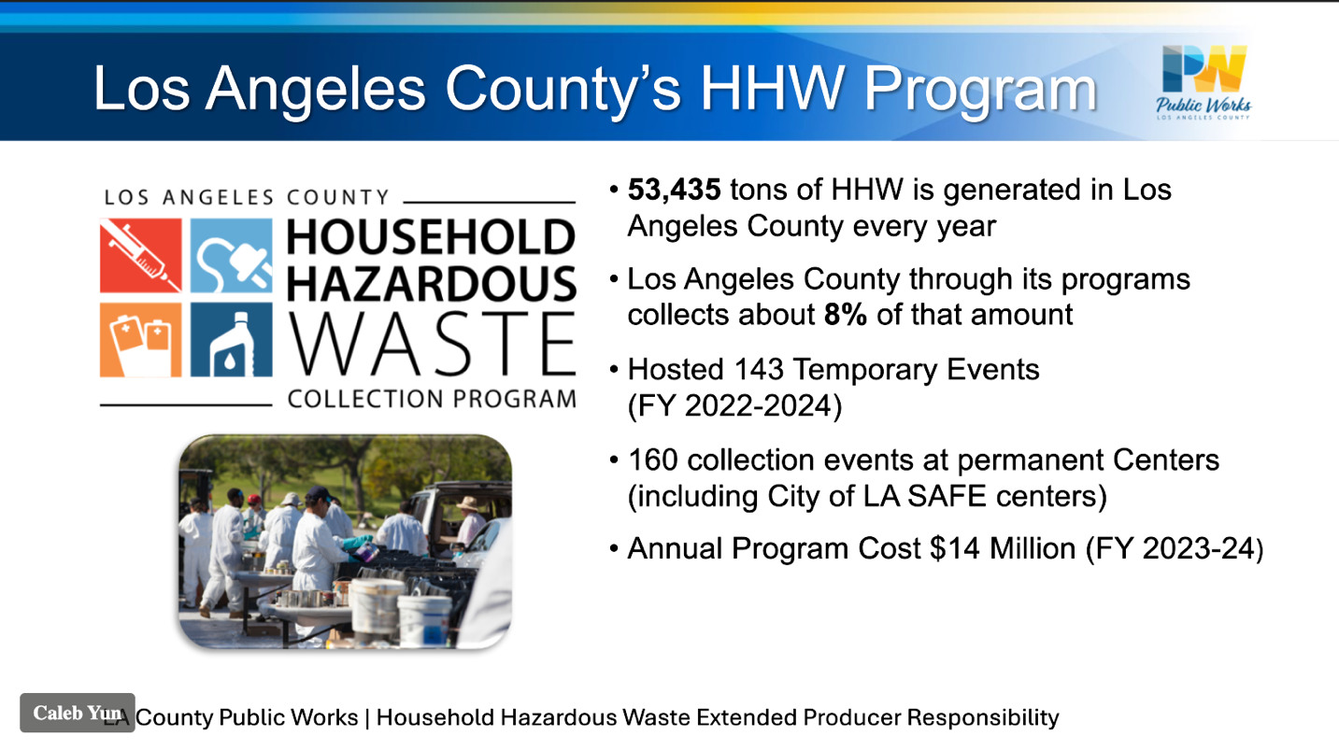

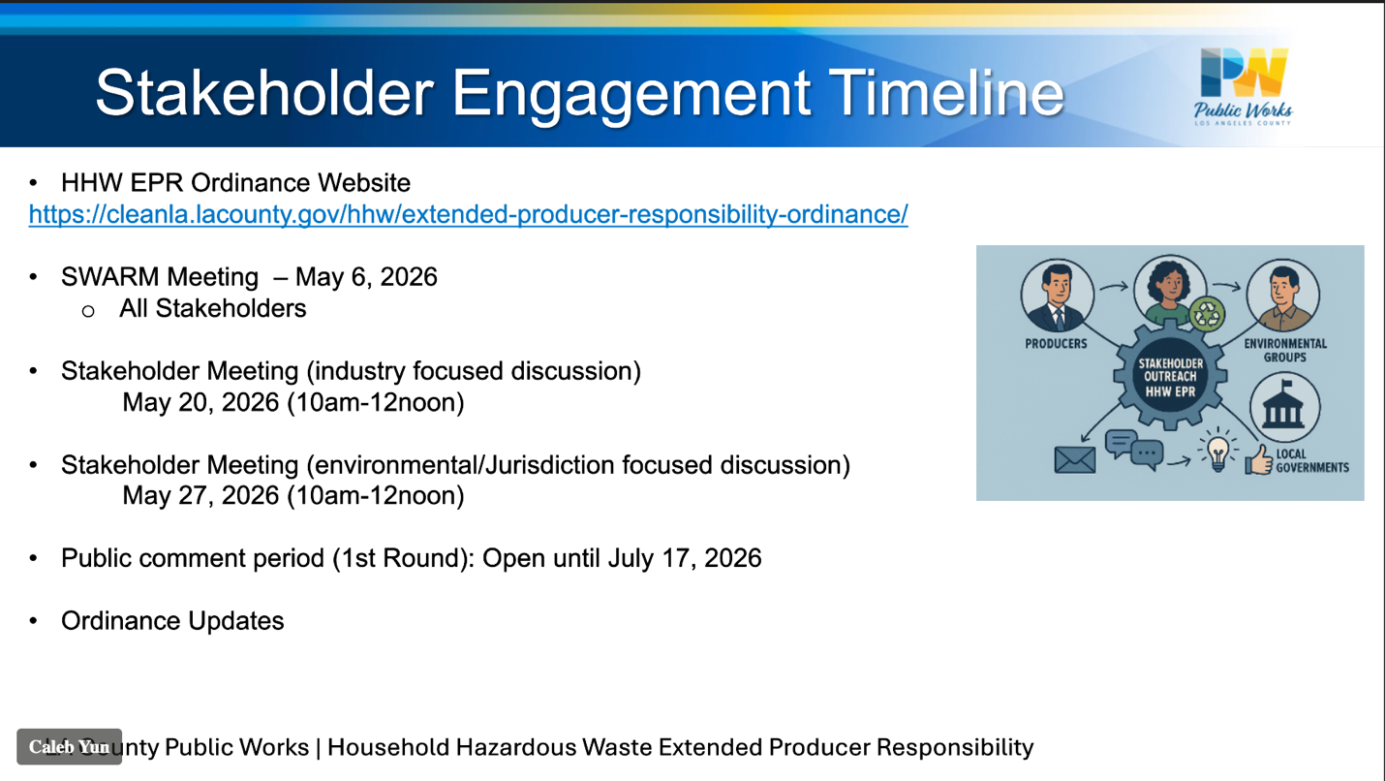

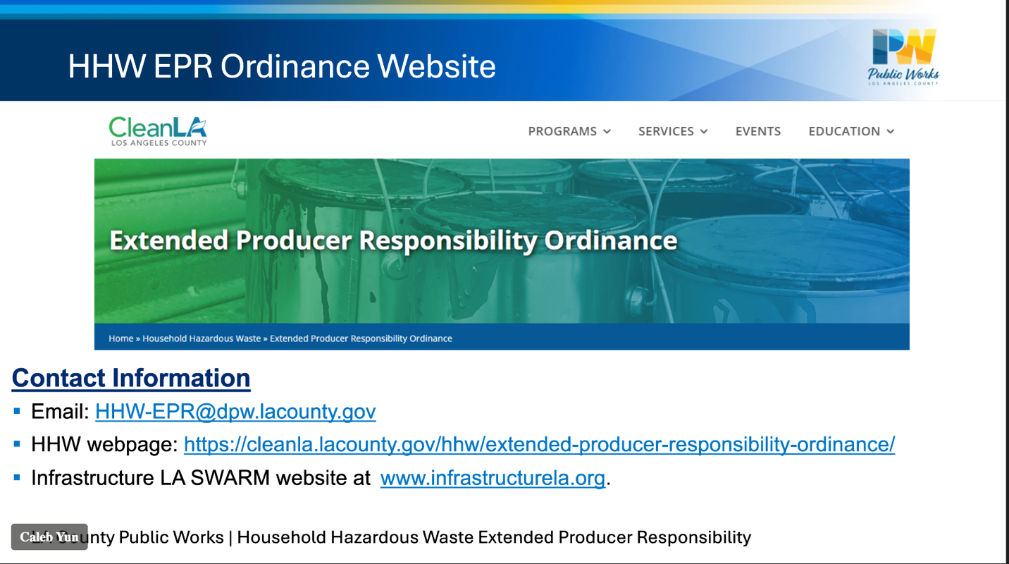

Questions and Answers

Prompted by LA County:

Q. Are the products listed in definitions exhaustive of all the products, or are those just examples of the primary HHW?
A. Not a fixed list. Covered products are defined broadly based on characteristics.

Q. Once the product is finalized, will it be incorporated into the language of the ordinance?
A. Will be referenced in approved ordinance and updated as new markets come to market.

Q. Will program costs be passed down to consumers form producers?
Heidi: yes, it can be. It’s a business decision. Investors watch closely and internalized costs are primary driver to get products redesigned. Retailers have a hard time with visible fees as they are hard to change frequently, track, etc. which is why EPR (producer funded) is better than product stewardship (visible consumer fee funded program)

Stakeholder Questions:

Q. How long before first stakeholder meeting will first draft of ordinance be released?
A. Looking to be released next week or at the latest, May 20.

Q. If City participates, can they get funding from County EPR Program PRO?
A. LA County is working on these details in their ordinance, but the plan is for PRO to fully fund education and outreach. City will need to work with County on helping with funding.

Q. If state adopts a statewide program with different materials in scope, how does that interact with the LA County ordinance?
A. This happened with pharmaceuticals and the statewide program will overtake the county ordinance IF there is a preemption clause.

Q. Has LA County identified any takeback locations? If producers are responsible for takeback, are they responsible for funding those takeback locations?
A. LA County has not identified these, and it will be the producers’ responsibility to identify these and fund. The draft ordinance includes minimum requirements for convenience.
Heidi: convenience is negotiated, and different products sold in different locations are considered to determine convenience. We can’t require one number for multiple plans unless they are coordinated. Some things need to be sent to different facilities depending on the product and can’t be taken back just anywhere.

Q. Is pressure treated wood on the list as a Covered Material?
A. LA County is still working on the covered materials and depends on feedback county gets from stakeholder meetings, so it is too early to answer this.

Q. If proposed ordinance is co-sponsored by LA County Public Health and Public Works, will all cities be included in LA County as not all have these departments?
A. LA County staff is looking into this. While LA County Public Health services many cities ion the county, it does not service all and those that it does not there is usually a signed agreement we would have for those cities to agree to participate in the countywide EPR program that the LA County Public Health Officer would have to sign off on.

Q. Does the draft ordinance include a needs assessment?
A. No, but we have a report posted on LA County’s webpage. Please review and send us your comments.

