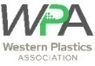
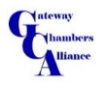






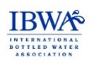
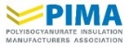
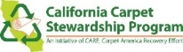

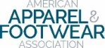


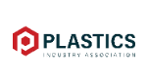
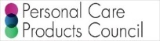




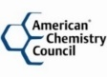
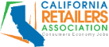


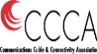





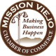

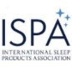





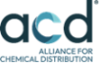






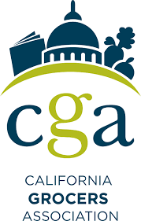



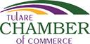





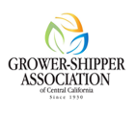
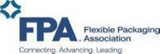


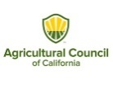




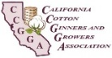
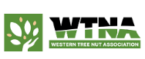
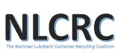

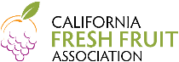


September 4, 2026
The Honorable Gavin Newsom
Governor, State of California
1021 O Street, Suite 9000
Sacramento, CA 95814
RE: Assembly Bill 2253 (Boerner) – REQUEST FOR VETO
Dear Governor Newsom:
The California Chamber of Commerce and the following listed organizations write to respectfully request that you veto Assembly Bill 2253, which passed the Legislature on August 30, 2026, and is now before you for signature. The bill as drafted creates a costly, California-only compliance regime that layers on top of the state’s existing extended producer responsibility programs (EPR) and pulls California out of step with the international standards the rest of the world, and much of producer community, already relies on. In doing so, AB 2253 undermines ongoing implementation of SB 54 (Allen), SB 707 (Newman) and other EPR programs and the innovative technologies necessary to recycle the different types of substrates, including paper, glass, plastics, textiles, and more.
AB 2253 Increases Significant EPR Compliance Costs Across Sectors and Programs
California businesses are in the middle of standing up compliance with SB 54 (Allen), the Plastic Pollution Prevention and Packaging Producer Responsibility Act, which already imposes substantial source-reduction, recycling-rate, and eco-modulated fee obligations on producers of all substrates that will be in the tens of billions of dollars. California businesses are also in the middle of standing up compliance with SB 707 (Newman), the extended producer responsibility program for all textiles, including clothing, that is expected to also be expensive. These are just a few of the EPR programs in California that rely on mass balance accounting.
AB 2253 adds another parallel verification and substantiation regime for recycled-content claims, with its own chain-of-custody methodology requirements that producers must build and maintain specifically for California, which is inconsistent with international standards. For companies operating nationally or internationally, this means maintaining a California-specific compliance track distinct from every other state and country they sell into, at a time when SB 54 implementation costs are already straining the same producers this bill regulates in the tens of billions of dollars. Furthermore, by rejecting the internationally recognized accounting methodology in favor of a narrow, identity-preserved standard, AB 2253 undermines the very investment needed to scale recycled-content supply and new recycling technologies to make circularity implementable and more cost-effective.
AB 2253 isolates California from the international standard the rest of the world uses.
ISO 14021:2026, “Environmental statements and programmes for products — Self-declared environmental claims,” is the globally recognized framework that governs how companies substantiate and label environmental claims, including recycled content, for markets around the world, including the European Union and other major trading partners. Rather than aligning California’s requirements with this internationally accepted standard, as the opposition coalition offered, AB 2253 adopts its own narrower, state-specific definitions and methodology, referencing only cherry-picked ISO chain-of-custody standards (parts of ISO 22095 and ISO 22095-2) while departing from the broader ISO 14021 framework that governs the claims themselves. The result is a product that may be fully compliant with the international standard the rest of the world uses and still fail to meet California’s AB 2253 bespoke standard, thereby forcing manufacturers to choose between serving the California market and maintaining a single, globally consistent compliance program. This adds tremendous costs and confusion.
Amendments were offered, but not accepted, that would have aligned AB 2253’s substantiation methodology with ISO 14021, which would prohibit waste-to-fuel from counting as post-consumer recycled content and would have prohibited any “book and claim” methodologies.
AB 2253 is unnecessary: California law already prohibits the conduct it targets.
California’s Unfair Competition Law, Business and Professions Code section 17200, broadly prohibits “any unlawful, unfair or fraudulent business act or practice” and any “unfair, deceptive, untrue or misleading advertising.” The False Advertising Law, section 17500, independently prohibits any statement a business knows or should know to be untrue or misleading. Together, these statutes already reach false or unsubstantiated recycled-content claims, and they are enforceable not only by the Attorney General and local prosecutors, but through a private right of action available to competitors and consumers alike, thereby giving California one of the most robust false-advertising enforcement regimes in the country without the need for a new, California-specific substantiation methodology.
For these reasons, we respectfully urge you to veto AB 2253. California already has existing laws that could be used to address any alleged false recycled-content claims. Creating a third, state-specific compliance regime that diverges from the international standards that producers, retailers, and trading partners already rely on will substantially increase costs for all extended producer compliance programs like SB 54 (Allen) and SB 707 (Newman).
Respectfully,

Corianna Miller
California Chamber of Commerce

On behalf of the following organizations:

California League of Food Producers
American Chemistry Council
California Retailers Association
Consumer Brands Association
Plastics Industry Association
Western Plastics Association
National Association of Printing Ink Manufacturers
Household & Commercial Products Association
Carpet America Recovery Effort (CARE)
International Bottled Water Association
Polyisocyanurate Insulation Manufacturers Association
Personal Care Products Council
SNAC International
National Confectioners Association
American Beverage Association
American Apparel & Footwear Association
Pet Food Institute
California Manufacturers & Technology Association
Western Growers Association
Brea Chamber of Commerce
Corona Chamber of Commerce
Gateway Chamber Alliance
Greater Bakersfield Chamber of Commerce
Lodi District Chamber of Commerce
Long Beach Area Chamber of Commerce
Mission Viejo Chamber of Commerce
Norwalk Chamber of Commerce
Palm Desert Area Chamber of Commerce
Napa Chamber of Commerce
San Juan Capistrano Chamber of Commerce
Santa Ana Chamber of Commerce
Torrance Area Chamber of Commerce
Yorba Linda Chamber of Commerce
Greater San Fernando Valley Chamber
Alliance for Automotive Innovation
EPS Industry Alliance
Alliance for Chemical Distribution (ACD)
Meat Institute
American Composites Manufacturers Association
The Vinyl Institute
Communications Cable & Connectivity Association
The Adhesive and Sealant Council
International Sleep Products Association
Danville Area Chamber of Commerce
Power Tool Institute (PTI)
Fontana Chamber of Commerce
PRINTING United Alliance
Spray Polyurethane Foam Alliance
Association of Home Appliance Manufacturers
Tulare Chamber of Commerce
La Cañada Flintridge Chamber of Commerce
The Carpet and Rug Institute
Consumer Healthcare Products Association
AMERIPEN
Dairy Institute of California
Wine Institute
Plastics Pipe Institute
Can Manufacturers Institute
CalAsian Chamber of Commerce
California Grocers Association
Agricultural Council of California
Flexible Packaging Association
California Strawberry Commission
Grower Shipper Association of Central California
California Rice
National Lubricant Container Recycling Coalition
Western Tree Nut Association
California Cotton Ginners and Growers Association
California Fresh Fruit Association
African American Farmers of California
Nisei Farmers League
Foodservice Packaging Institute

cc: Christine Aurre, Legislative Affairs Secretary, Office of the Governor
Megan Merkelburg, Acting Deputy Leg. Affairs Secretary, Office of the Governor
Yana Garcia, Secretary for Environmental Protection

CalRecycle estimates a minimum of $21 billion in the latest SRIA, 2025.

